2.Perform basic Image Handling and processing operations on the image is to read an image in python and Convert an Image to Blur using Gaussian Blur

**AIM:**

To read an image and apply Gaussian Blur using OpenCV in Python.

**PROCEDURE:**

* 1. Install OpenCV (if not already installed):pip install opencv-python
  2. Import required libraries:Use cv2 for image processing.
  3. Read the image:Use cv2.imread() to load the image.
  4. Apply Gaussian Blur:Use cv2.GaussianBlur() with a specified kernel size.
  5. Display the images:Use cv2.imshow() to show both original and blurred images.
  6. Wait for a key press & close windows:
     1. Use cv2.waitKey(0) to keep the image open until a key is pressed.
     2. Use cv2.destroyAllWindows() to close all image windows.

**PROGRAM:**

import cv2

image = cv2.imread(r"C:\Users\sr051\OneDrive\Desktop\ITA0504-CV\tree.jpg")

if image is None:

print("Error: Image not found or path is incorrect.")

else:

blurred_image = cv2.GaussianBlur(image, (15, 15), 0)

cv2.imshow("Original Image", image)

cv2.imshow("Blurred Image", blurred_image)

cv2.waitKey(0)

cv2.destroyAllWindows()

**INPUT:**

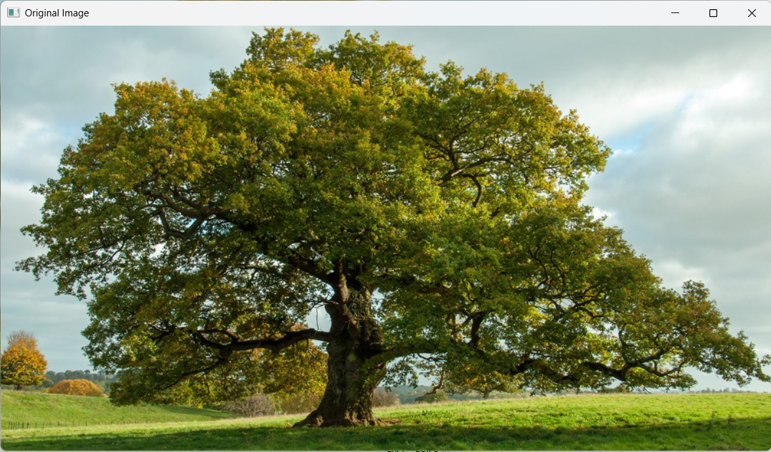

**OUTPUT: Blurred image**

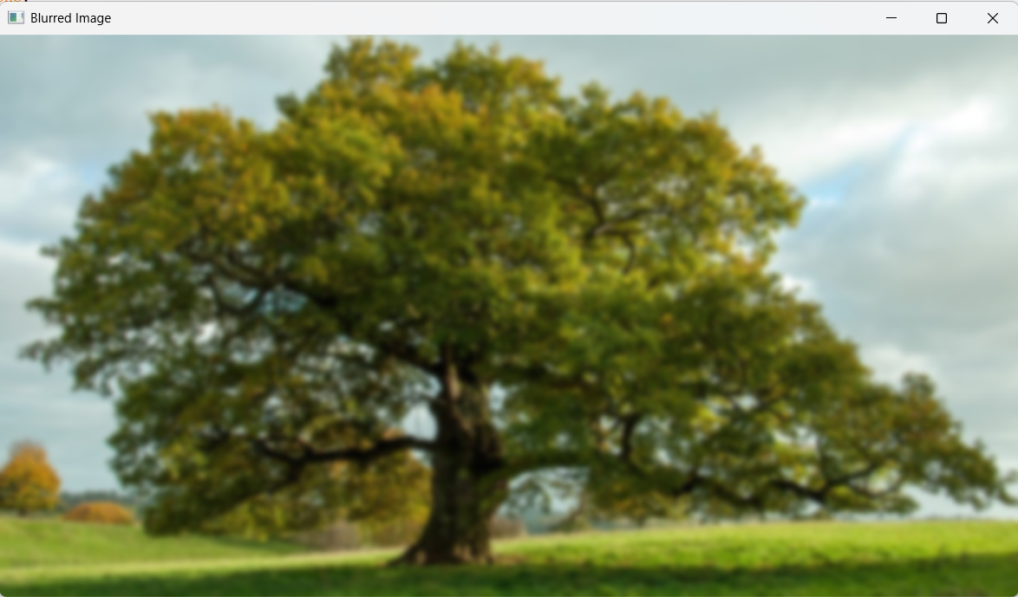

**RESULT :**

Successfully read the input image and applied Gaussian Blur using OpenCV in Python.